## 2.1 State of power (SOP)

**2.1.1 Feature Objective:**

SOP is defined as the maximum allowed constant pack discharge power and maximum allowed constant pack charge power (both quantities positive) for the next 1 second, at the present operating point (SoC, SoR, temperature). The SOP feature will calculate those two quantities along with charge and discharge current limits and broadcast all those four quantities through CAN bus to vehicle controller.

**2.1.2 Functional Description:**

Power limits will be calibratable based on cell characteristics. Power limits as a function of SOC and temperature will be needed for each cell which will be scaled to the pack level. So the table of SOC-temperature – Power Limits will be calibrated at the pack level. These power limits will be short term power limits and will be continuously calculated based on SOC and temperature. There will be charge and discharge power limits separately. These power limits will also be derated for safety reasons. In case of faults from VIT monitoring, the derate factor will be further modified. These derated charge and discharge power limits along with the minimum and maximum voltage limits will be used to calculate the charge and discharge current limits.

The process to compute power limits and current limits are described as follows.

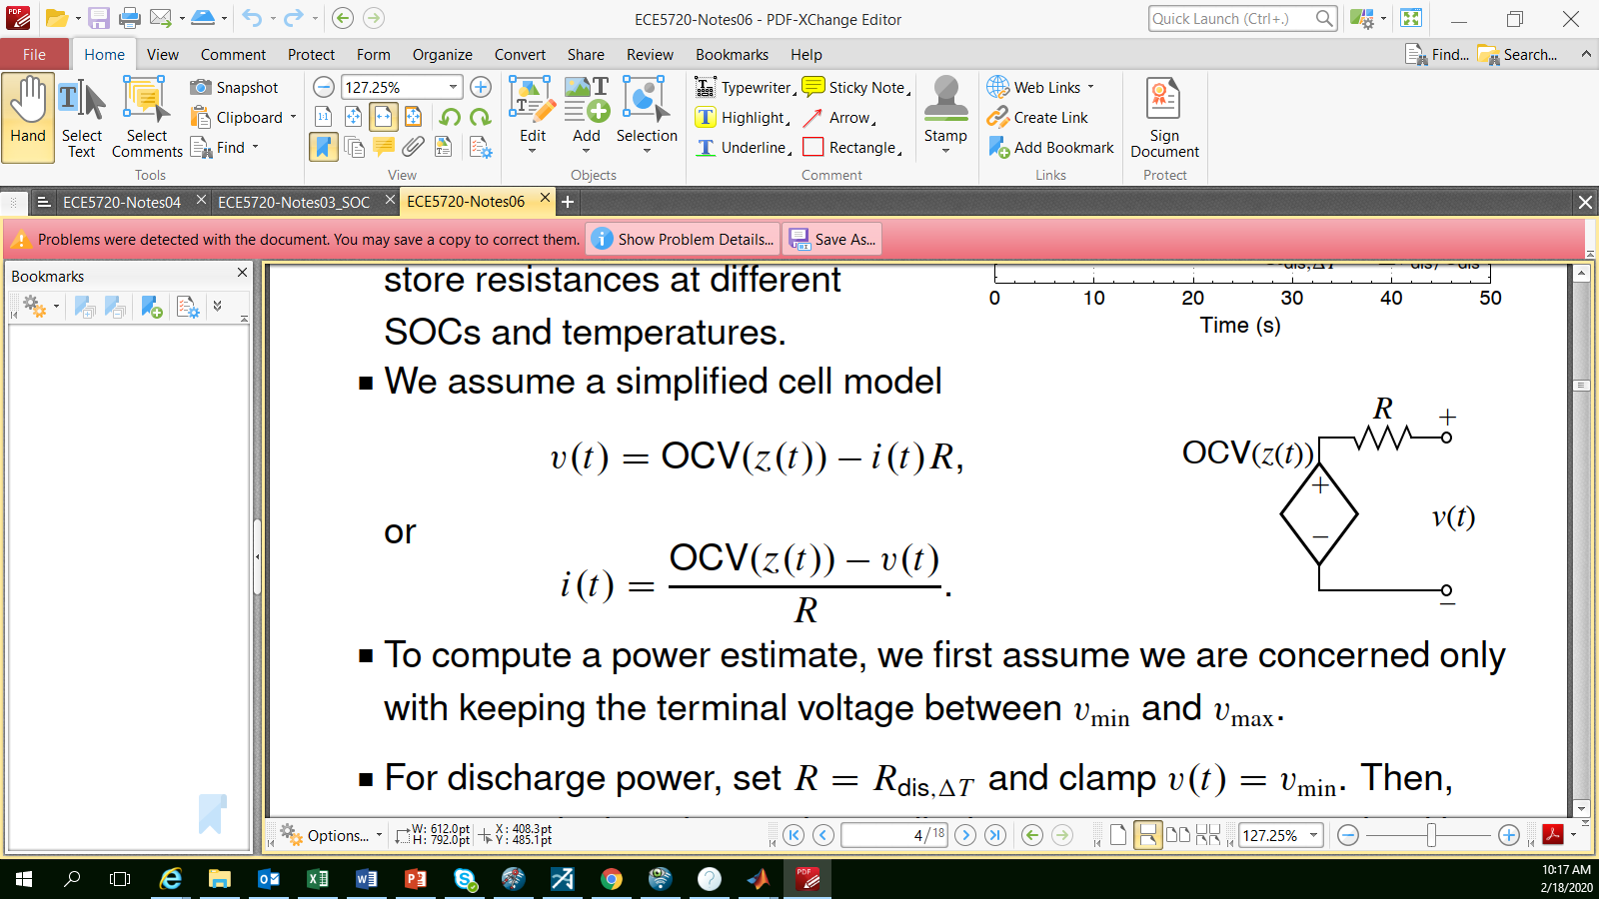

**Figure 2.1 Simplified Cell Model**

We assume the cell model is simplified as shown in Figure 2.1, where OCV represents the open circuit voltage whose value depends on z(t), the cell SOC value at time index t, R represents the internal resistance of the battery and v(t) is the cell voltage. This electric circuit can be described as

$i\left(t\right)=\frac{OCV\left(z\left(t\right)\right)-v(t)}{R}$

To compute the power limit, we will assume we are only concerned with keeping the cell voltage between $v_{min}$ and $v_{max}$. The maximum discharge current is constrained by $v_{min}$ and can be calculated as 8$f*ZP#NK8OERila

$i_{max,n}^{dis,vol}=\frac{OCV(z_{n}\left(t\right))-v_{min}}{R_{dischg}(z\left(t\right),T_{cell})}$,

Where $R_{dischg}(z\left(t\right),T_{cell})$ represents the discharge internal resistance whose value is a function of cell SOC and cell temperature, and the pack discharge power limit can be obtained as

$P_{max}^{dis}=N_{s}N_{p}v_{min}\min_{n}\left(i_{max,n}^{dis,vol}\right)$,

where $N_{s}$ denotes the number of cells in series and $N_{p}$ denotes all the cells in parallel. Note that in the above equation, we take the minimum of the maximum allowable current for all cells. The reason for this is that we need to insure every cell has its current within the safe range when we compute power limit.

To compute the charge power limit, we clamp the cell voltage as ${v\left(t\right)= v}_{max}$ since we are charging the battery and we can set battery voltage to its maximum allowable value. Now the maximum magnitude current is calculated as

$i_{min,n}^{chg,vol}=\frac{OCV(z_{n}\left(t\right))-v_{max}}{R_{chg}(z\left(t\right),T_{cell})}$,

where the sign of $i_{min,n}^{chg,vol}$ is always negative and min here represents the maximum magnitude although its value is negative. The pack discharge power limit is then can be calculated as

$P_{min}^{chg}=N_{s}N_{p}v_{max}\min_{n}\left(i_{min,n}^{chg,volt}\right)$.

From the above calculation, it is clear that except for the OCV, all the other quantities involved in the calculation of charge and dis-charge power limit are constants.

After we get the charge and discharge power limits, the charge current limit can be obtained as

$I_{ch}= \frac{P_{ch,cell}}{v_{max}}$

where $P_{ch,cell}=\frac{P_{ch}}{N_{series}}$, and the discharge current limit can be calculated as

$I_{disch}= \frac{P_{disch,cell}}{v_{min⁡}}$

where $P_{disch,cell} is\frac{P_{disch}}{N_{series}}$. The detailed implementation of the algorithm can be found in the Simulink file.

**2.1.3 I/O description:**

The SOP module requires the dynamic I/O shown in the following table

|  |  |  |  |
| --- | --- | --- | --- |
| **Signal(s)** | **I/O** | **Description** | **Units/comments** |
| sop_CellSOC | Input | All Nseries filtered OCV estimates, from SoC module | V |
| sop_CellTemp | Input | All Nseries cell temperatures, estimated from module temperatures | °C |
| sop_ChgStatus | Input | charging status, 1 means charging, 0 means otherwise | unitless |
| sop_DisChgStatus | Input |  | unitless |
| sop_CellTempHighFault | Input | discharging status, 1 means discharging, 0 means otherwise | unitless |
| sop_PackVoltFault | Input | pack voltage fault signal | unitless |
| sop_PackCurrentFault | Input | pack current fault signal | unitless |
| sop_DischgPwLim | Output | An estimate of available pack discharge power | W |
| sop_ChgPwLim | Output | An estimate of available pack charge power | W |
| sop_DischgCurrentLim | Output | An estimate of available discharge current | A |
| sop_ChgCurrentLim | Output | An estimate of available charge current | A |

**2.1.4 Fault Management**

When there is either pack current fault, pack voltage fault or cell temperature high fault occur, a derating factor between 0 and 1 will be used to multiply the charging and discharging power, and the resulting charging current and discharging current. Therefore, at the time of those faults, the power limit and the associated maximum allowable current would be reduced.